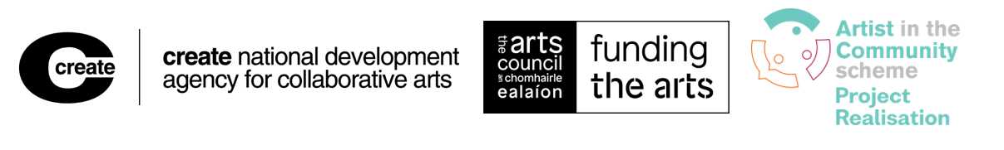ARTIST IN THE COMMUNITY SCHEME 2026
Project Realisation Awards Application Form
Deadline: 5 pm, 28 September 2026
1. General
1.1 Please provide
Name of community group or name of the organisation who is supporting the community in writing this application (the applicant)
Address:

Telephone:
Email:
Contact person
Pronoun(s)
Why are we asking for your pronouns?
Location of project (local authority area):
Title of arts project
Amount sought from AIC Scheme
Name of artist(s)
Pronoun(s)
Artist’s address
Location of project (local authority area)
Telephone
Email
Website/Social media handles relevant to project/artist/ community
1.2 Artforms/arts practices relevant to your application
Indicate (x) which artform/arts practice is relevant to your application. If ‘More than one art form’ please specify using 1,2,3…

Architecture |  | Visual arts |  | Theatre
Circus |  | Dance |  | Film
Literature |  | Music |  | Opera
Spectacle |  | Street arts |  | Traditional arts
More than one art form |  | Multi disciplinary arts, |  | Comedy

1.3 Social context relevant to your application
Indicate (x) which social context is relevant to your application- Indicate one only
arts and disability☐ | communities of place☐ | prisons / justice☐
arts and health☐ | cultural diversity☐ | intergenerational☐
communities of interest☐ | older people☐ | other☐
If other, please state: ____________________

1.4 Did you seek support from Create?
Please indicate (x) if Create provided advice to either the community or the artist regarding this application/proposal. We ask this so that we can ensure we are offering the right supports to applicants.

YES, we sought and received advice from Create | ☐
NO, we did not seek or did not receive advice from Create | ☐

If YES, how was Create’s advice received?
By phone | ☐
By e-mail | ☐
In person/video meeting 1:1 | ☐
At an AIC Scheme Information Session | ☐
Other | ☐

Who got advice?
The community | ☐
The artist | ☐
Both | ☐

2. Tell us about yourself
Collaborative arts projects are relational; they are built on relationships between artists, communities, organisations, and partners who work together toward a shared goal.
When you apply, assessors need to understand how these relationships work.

For example:
- How did the relationship begin, and why?
- What values do you share?
- What ambitions do you have in common, and how do they complement each other?

Thinking about these questions early benefits everyone involved. It helps you clarify why you came together and gives a clear picture of how the partnership works. This will also be useful later when you evaluate the project.
In this section, make sure you include the voices of everyone involved.
2.1 To be completed by - the lead applicant- This is either the community group or host /support organisation who are supporting the community
Briefly describe your group / organisation and the main focus of your work. (max. 600 characters)

2.2 To be completed by – the collaborating community group members (not the lead organisation)
This section must demonstrate the voice of the collaborating community members.
Briefly describe your community’s involvement in the shaping of this proposal. Include
- the consultation process with the artist and
- what you believe are your shared interests and values. (max. 600 characters)

2.3 To be completed by - Artist
It is important that you help those involved in assessing the application to understand the nature of the relationship between you and the collaborating community members. In describing this consider questions like
- how you first met,
- what has been the consultation to date,
- what are your shared interests and values. (max. 600 characters)

3. Your proposal- to be completed by the community
The AIC scheme supports meaningful collaboration between artists and communities. This means the artist and community should plan and deliver the project together. Group ownership of the art should be clear at every stage.
For this reason, this section must be completed by the community group — not by the artist. If an organisation is involved they can support the community in completing this section.

This approach ensures:
- The panel hears the voices of everyone shaping the project, not just a single author.
- The community’s needs and goals are taken into account.

Writing from these perspectives also helps later evaluation. It allows everyone involved to compare the project’s original goals and ambitions with the outcomes and outputs showing what was achieved and what may have changed along the way.
3.1 Summary of your proposal
Summarise your proposal in up to three short points. Please explain:
- What you want to do
- How you will do it
- Why it deserves support (Max. 600 characters)
Note: If your application is successful, this summary may be published on Create’s website. Write it with a wider audience in mind, not just the assessment panel.
3.2 Details of your proposal
Collaborative arts is an art practice that often brings people together to explore an issue or ambition in their community, in collaboration with an artist or artists.

Strong collaborative projects combine:
- Organisational work (For example, planning, communication, management)
- Artistic work (For example, filmmaking, theatre, visual arts)

Good projects are also inclusive and responsive to the social or cultural context in which they take place.

Together, these organisational and artistic aspects create:
- Outputs: short-term activities like exhibitions, performances, books, films, or videos.
- Outcomes: longer-term social or behavioural changes/transformation

When answering the following questions, address both the practical and creative sides of your proposal. Include:
- Your goals and ambitions
- The wider context for the work
- Any other relevant details (such as schedules, key partners, or administrative, technical, or financial information)
Please also refer to Objectives and priorities of the award (Section 1.2) in the Artist in the Community Scheme Guidelines.
Description of the Project - Aims and objectives of project
- a) Please describe the project, include the

- aims and
- objectives of project.
Elaborate on what you want to do, why you want to do it and how. (max. 3000 characters)
- The duration of the project and key activities for your proposal
Please list the key activities involved in your proposal, along with your planned start and end dates. (max. 900 characters)

To help us assess the feasibility of your project, indicate the approximate amount of time you expect to spend on each activity. Time should be described in days (e.g., ½ day, 1 day, 7 days, 31 days, etc.). If your proposal only involves one activity, simply list that activity.
- Anticipated outputs and outcomes of the project
Please describe the intended
outputs and

outcomes. (max.900 characters)
Consider, what trace might the project leave behind? Does it provide a ‘use-value’ for the community after the conclusion of the project, for example benefits for the community, audiences, broader community and other stakeholders?
- Publicity
How do you intend to publicise the project?
Posters | x | Press releases |  | Internet/E-mail
Social Media |  | Leaflets |  | Mail shots
Other, please specify
Please describe your target audience for this project and how you will engage with it. Be as specific as possible - include demographics and locations. (max 900 characters)
- Documentation
Please describe how you intend to document the progress and outputs of the project. (max. 900 characters)
The main stages or elements of the project must be documented, through high quality visual record for example photography, video or film recordings. See Documentation (section 4.6) in the Artist in the Community Scheme Guidelines.

- Monitoring and evaluation
Collaborative art is a process-based practice. Because of this, it is important to plan how the project will be monitored and evaluated as it happens. For more detail, see See Reporting, Monitoring and Evaluation (section 4.7) in the Artist in the Community Scheme Guidelines.

In this section, we ask you to think about:
- How you will record and track the project’s activities, timetable, budget, quality, and progress towards its goals.
- How you will show the relationships between everyone involved (for example the artist, the community and the organisation- if there is one) and make sure all their goals are part of the planning and actions.
- How the quality of these relationships might affect what happens in the project.
- How you will record or describe any changes or adjustments that happen during the project.
- How you will include other people’s views and experiences in the evaluation.
Please describe the methods you intend to use to monitor the project. (max. 900 characters)
Please describe the methods you intend to use to evaluate the project. (max. 900 characters)
3.3 Your application and the assessment criteria
Please describe how your proposal meets the assessment criteria for the Project Realisation Award . (max. 900 characters)
For details of the assessment criteria, see Criteria for assessing all applications (section 4.3) in the Artist in the Community Scheme Guidelines

4. Expenditure, income and amount requested
You must use the Budget Excel template provided to you online to calculate expenditure, income and balance related to your application (see below sample).
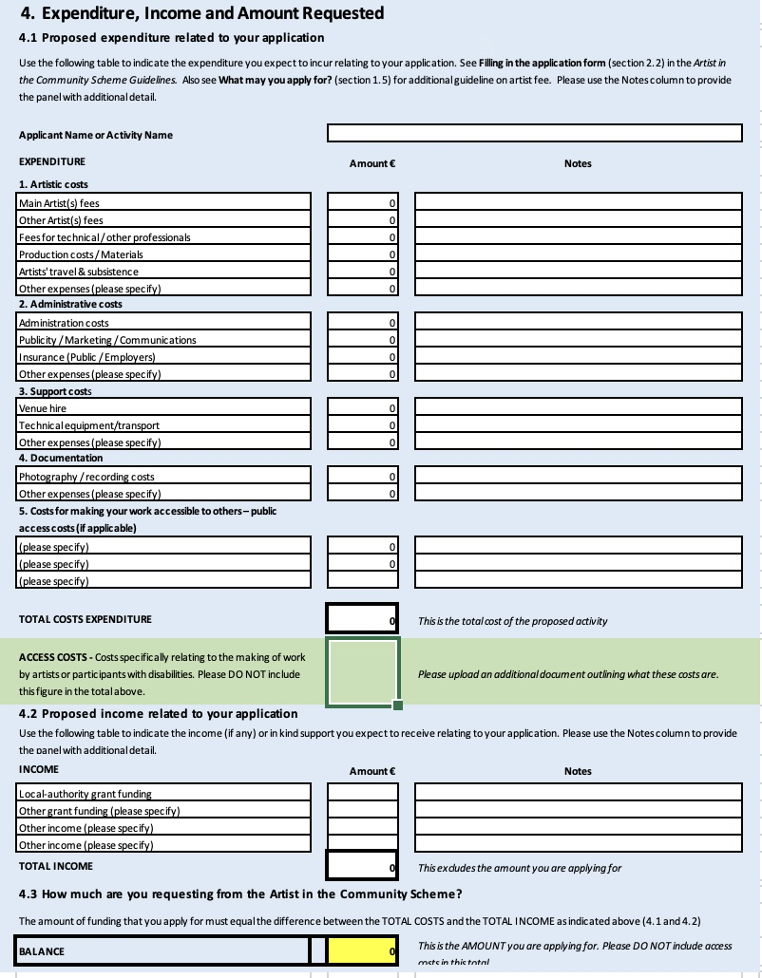
In the online application you will be asked to upload the budget and provide the below details:
Total Costs Expenditure - This is the total cost of the proposed activity
Access Costs - Costs specifically relating to the making of work by artists or participants with disabilities. Please DO NOT include this figure in the total above.
4.2 Proposed income related to your application

4.3 How much are you requesting from the Artist in the Community Scheme?- BALANCE

5. Artist’s statement- to be completed by artist(s)
This section must be completed by the Artist, to clarify the project from the artist’s perspective.
5.1 Tell us about yourself
Briefly describe
- who you are and your current preoccupations or interests as an artist (main focus of your work).
- What have you done? Highlight your most recent artistic achievements- relevant to your collaborative arts practice.
- Tell us about your collaborative arts practice. Outline your collaborative methodology - how you work with/engage with/ co-create with the communities you work with (max. 1800 characters)
5.2 Career stage
In line with Create’s and the Arts Council’s commitment to supporting artists at key stages of their career, which of the following (if any) best describe where you see yourself in your career, specifically related to your collaborative arts practice?
Early Stage/Emerging☐ | I don’t identify with any of these ☐
Mid-Career☐ | Prefer not to say ☐
Established ☐
5.3 Equality, Diversity and Inclusion
In line with the Arts Council's Equality, Diversity and Inclusion Policy & Implementation Plan, we have included some questions below which help us to understand more about the artists and individuals with whom we engage. This information has no bearing on your application's assessment, and is purely for research and analysis purposes. Data collected will only be used in an aggregated anonymised fashion. Research information will not be disclosed to any external third party without de-identification except where an organisation is acting on behalf of Create and with its consent and for a research purpose. See Data protection in the Artist in the Community Scheme Guidelines.
Gender
Female ☐ | Male ☐
Non-binary ☐ | Prefer not to say ☐
Ethnicity
Black or Black Irish – African☐ | White Irish ☐
Black or Black Irish – any other Black background☐ | Any other White background ☐
Asian or Asian Irish – Chinese ☐ | Irish Traveller ☐
Asian or Asian Irish – any other Asian background ☐
Mixed ethnic group (please state which):
Any other ethnic group (please state which):
Prefer not to say ☐
Language

What is your first language?
Disability
Do you consider yourself to have a disability?
Yes ☐ | No ☐ | Prefer not to say ☐
EDI Survey
As part of our commitments within Create’s Equality, Diversity and Inclusion (EDI) policy (we are trying to gather more consistent monitoring data across our programming work and within the organisation.
We would greatly appreciate your input into this Survey which aims to capture and better understand the diversity of those we engage with. All analysis will be conducted in line with GDPR regulations and anonymity is guaranteed at all times.
Here’s the anonymous form https://forms.office.com/e/aH0aMSdg3a
5.4 Artist’s statement
- Describe the artistic concept of the proposed project, and consider how it relates to the goals, needs or ambitions of the collaborating community. (max. 1800 characters)

- Describe your approach to working collaboratively with the group. (max. 1200 characters)
This is your process or methodology for engagement which must be collaborative. Collaborators should have a direct influence on the process and product, from start to finish (For example, in the planning, making, presentation and evaluation of work) See Objectives and priorities of the award (section 1.2) in the Artist in the Community Scheme Guidelines
- Outline what impact you believe this project will have on your own artistic development (max. 900 characters)
5.5 Post graduate students
If you are a post graduate student, please name the post postgraduate course and outline how or if the project relates to your course.
See Who may not apply? (section 2.3) in the Artist in the Community Scheme Guidelines

Course title
Outline if / how the project relates to your course

5.6 Artist’s CV
Please attach artist(s) CV. (max. three pages). See Supporting material (section 2.8) in the Artist in the Community Scheme Guidelines
5.7 Supporting material
See- Supporting material (section 2.8) in the Artist in the Community Scheme Guidelines
- Detailed up-to-date CVs (max. three pages) for all the artists involved in the proposed project
- Examples of previous work- relevant to the proposed project (See Acceptable file formats under section 3.1)
- Evidence of any financial support or sponsorship identified in the project budget
- Additional material required in certain circumstances:
For example, if you are seeking access costs
- to support work by individuals with access requirements,
- or to support access to your work by audiences with disability requirements,
Please provide a document or you can use this optional Disability Access Costs template to outline these costs and how you arrived at them as part of your supporting documentation. Please also ensure that you include this amount as part of your budget.
IMPORTANT: If you do not submit the required supporting material, your application will be deemed ineligible.

6. Declaration
6.1 Items that are mandatory for certain applications (check those that apply to your application)
- The Arts Council requires all individuals and organisations providing services (e.g. cultural, recreational, educational) to children and young people under the age of eighteen to have suitable child-protection policies and procedures in place. When making an application, you must indicate whether or not your proposal is relevant to this age group.
Yes/No
If you answer ‘Yes’ to this question and your application is successful, as a condition of funding you will be required to confirm and demonstrate that you have suitable child-protection policies and procedures in place. Please see www.tusla.ie for more information.
- Does your proposal involve working with vulnerable persons?
Yes/No
If you answer ‘Yes’ to this question and your application is successful, as a condition of funding you will be required to submit an acknowledgement that you adhere to the National Policy & Procedures on Safeguarding Vulnerable Persons at Risk of Abuse (see here)
- Does your proposal involve working with animals?
Yes/No
If you answer ‘Yes’ to this question and your application is successful, as a condition of funding you will be required to provide a copy of your Animal Welfare Protection Policies and Procedures.

6.2 Declaration
This must be signed both by a representative of the community and by the artist.
Where there is more than one artist, one signature (the nominee) will suffice.
We have read the award conditions and guidelines and agree to be bound by them
We certify that the information in this application is correct to the best of our knowledge.
We declare that there is no duplication of public funding for the supported activity.
If successful, we (artist and community representative) agree to attend a 2 hour training session on 2 December 2026
Community/ Group:
Name and position: (Block Letters)
Signed: | Date:
Artist
Name: (Block Letters)
Signed: | Date:

6.3 Contact Opt-in
Please note that basic contact information you provide may appear in a database we use to inform beneficiaries and service users about our activities. This includes sharing information with you via an eBulletin and connecting with you by email to organise and promote events relevant to collaborative arts practice and participation in the arts.
I agree to allow Create to store my or my group’s/organisation's contact details on a database held for these specific purposes.

Yes / No

