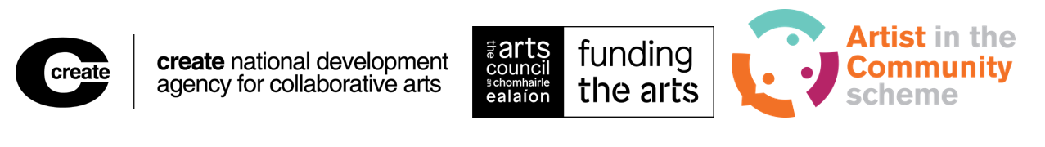

ARTIST IN THE COMMUNITY SCHEME 2026

Research & Development Award and Project Realisation Award

Guidelines for Applicants
Contents
Introduction 3
Note for people with disabilities or access requirements 6
1. About the Artist in the Community Scheme Awards 8
1.1. Deadline for submitting applications 8
1.2. Objective and priorities of the award 8
2. What awards are offered in the AIC Scheme? 10
2.1. Who is eligible to apply for the AIC Scheme? 14
2.2. Who is the applicant? 15
2.3. Who may not apply? 16
2.4. What funding may you apply for? 18
2.5. Access costs for artists or participants with disabilities 20
2.6. What you may and may not apply for 22
2.7. Eligibility criteria 23
2.8. Supporting material 24
3. Making your online application 27
3.1. Prepare your supporting material 28
4. Processing and assessment of applications 30
4.1. Overview 30
4.2. The assessment process 30
4.3. Criteria for assessing all applications 31
4.4. Peer Assessment Panels 35
4.5. Outcome of applications 36
4.6. Documentation 38
4.7. Reporting, Monitoring and evaluation 39
5. Glossary 43
Data protection 44

Introduction
Why you need to read these guidelines before starting your application
Save yourself time
It is vital that you read these guidelines before starting your online application. It will take you about one to two hours, but it is worth it. Reading these guidelines will help you to make sure the award you apply for is right for you and that you are eligible.
If you want to find out if you are eligible for one of the two awards, see Section 2.1
There are two awards you can apply for:
- The Research & Development Award is for artists who wish to research and develop a potential project with a community (see Section 2)
    - Award funding ranges from €3,500 to €4,500 for the Research & Development Award
- The Project Realisation Award is for communities of interest or place (or their representative organisations) planning a project with an artist (see Section 2)
    - Funding can be up to €15,000 for the Project Realisation Award
Give yourself time to gather your supporting materials
You also need to read these guidelines so you can prepare the supporting material we require
Give yourself the best chance – this scheme is highly competitive
This is a highly competitive scheme. We get a lot of applicants for both awards under the AIC Scheme, and cannot fund them all.

Important:
- If you have gotten a Research & Development Award before, this does not guarantee you success if you apply for a Project Realisation Award.
- You do not have to apply for a Research and Development Award before applying for a Project Realisation award. However, we do advise that you consider doing so. We have observed that people who have completed a period of research and development submit stronger Project Realisation applications.
- To give your application the best chance, please use the supports we offer (mentioned below).
Want feedback? We are happy to provide feedback on unsuccessful proposals. To get this feedback, you need to contact us within two weeks of an unsuccessful application.
How to get help with your application
If you have a technical query about using the online application form, please read the troubleshooting document and email info@create-ireland.ie or call 014736600.
If it is your first time applying to the AIC Scheme, we encourage you to:
- attend an information session (these last for about two hours)
- book a one-to-one advisory session at least three weeks before the deadline
If you would like to book a one-to-one advice session contact Create. Create is the national development agency for collaborative arts. You can contact Create on:
- tel: (01) 473 6600, or
- email: info@create-ireland.ie
Audio Guidelines
We provide audio guidelines, which can be used in conjunction with the written text, or to
assist those with additional access needs.
Glossary
There are certain specialist terms or terms we have to use in a particular way. For example, ‘community’ and ‘collaborative’. We have listed these in an A-Z Glossary in Section 5. Please refer to these if you come across a word or description you don’t understand.

Planning your application from start to finish
Four to six weeks before deadline
Read these guidelines – two hours
Read the reference only application form – 15 minutes
Attend an information session in person or online – two hours
Book a one-to-one advisory session – 30 minutes
Three weeks before deadline
Complete your answers in the reference only application form – two hours
Prepare and collect your support materials – one hour
One to two weeks before deadline
Complete the online application form – one hour
Remember to upload your support materials in the correct formats (see Section 3.1)
You can save your application and come back to it later
Check the troubleshooting document and contact Create if you have any technical issues – we will need time to help you with any problems
Week before the deadline
Do not wait until the deadline to complete your application as the IT system will be under pressure

Note for people with disabilities or access requirements
Create and the Arts Council aim to make the application process accessible to all. We have increased supports to remove barriers for applicants to Artist in the Community Scheme awards.
These additional supports may include:
- translation to or from other languages. Applicants may choose to write their application in a language other than English. We will pay for translation into English so that the application can be evaluated
- Irish Sign Language (ISL) interpretation for advisory sessions and information sessions
- transcription of audio and video files if applicants are unable to apply using the online form (a transcript is a written document)
If you feel your needs are not included in these supports, please contact us and we will do our best to support you.
We will do everything we reasonably can to help people with disabilities or access requirements who are eligible under the conditions of the award. To find out more please contact Create as early as possible before the closing date.
If you would like to book a one-to-one session to discuss your access needs (for example, support with your application such as translation, guidance on personal access costs within the project) contact Jane O'Rourke on info@create-ireland.ie or 014736600.

About the Artist in the Community Scheme Awards

Deadline for submitting applications
We must receive your online application by: 5 pm, Monday, 30th March 2026

Objective and priorities of the award
The objective of the Artist in the Community (AIC) Scheme is to encourage meaningful collaboration between:
- communities of place (this means people brought together by a shared place, for example where they live, their place of work, and so on) or communities of interest (this means people who are united by a specific interest, for example climate, housing, migration and so on), or both, and
- professional artists
Applications to the awards must meet the assessment criteria (see Section 4.3).

You must also feature or reflect the following 6 priorities in your application.
Priority 1: Value and encourage collaboration
You should value the creative contributions of all collaborators while providing opportunities for artistic challenge and experimentation
Priority 2: Support multiple voices being included
You should make sure to include multiple voices when you are:
- defining the values, beliefs and purpose of the project
- making practical, artistic, and conceptual decisions for the project
Priority 3: Value artistic quality and collaboration with community
You should consider the artistic quality and the quality of the engagement between artist and collaborators. Think about these throughout the artistic work including:
- planning
- making
- presenting your work
- evaluating it
Priority 4: Show us how all partners are included
You need to show us that there is active support and commitment from all collaborators and partners. We also need to see clear organisation. For example, do all current collaborators and partners in the project understand:
- the purpose of the project?
- where it's going?
- their roles in it?
Priority 5: What is the project about, and how will the project respond to the community’s needs or interests?
Does the project respond to any particular needs or interests the community has identified? Tell us if there are any ways the project could be valuably used, for example, how might aspects of the project continue after the end of the AIC Scheme award?
Priority 6: Consider what may be needed to support the project longer term
It’s important to consider what happens after your project is finished. Can aspects of the project continue after the end of the AIC Scheme award? If so, what are the things you will need to consider?
This might include:
- organisational skills
- introductions to artists’ networks/ other partners
- practical skills like training to complete funding applications

Things to consider and tips for your application
Questions to consider
- How do your methods reflect the values of your project and collaboration proposed?
- Will you need to consider power differences that might limit or create barriers to others’ engagement? For example, does the community think that the artist has more power in the interaction? This is important to discuss with the community as this could mean that some community members may not want to take part.
- Are there any ethical considerations that need to be considered? For example, are members of the community vulnerable adults? Is the work dealing with a challenging topic? How will the artists and community members ensure that everyone is protected from harm?
In Section 4.7, we have included a simple illustration showing the phases of collaborative art projects.

What awards are offered in the AIC Scheme?
There are two awards offered in the AIC Scheme:
- Research & Development Award
- Project Realisation Award
All artform areas are eligible for funding through the AIC Scheme; architecture, circus, dance, film, literature, music, opera, street arts and spectacle, theatre, traditional arts, and visual arts.
Research & Development Award
The Research & Development Award aims to support proposals from professional artists who wish to collaborate artistically with:
- communities of place
- communities united by a specific interest, or
- both
These communities must be made up of non-arts professionals. See the Glossary in Section 5 to read more about what we mean by “community”.
This award is open to artists who wish to research and develop a project in a community or social context. It gives artists the opportunity to explore or test ideas. Research and development phases are expected to be ambitious, innovative and visionary.
Artists are the applicants
In this strand, artists are the applicants. They must plan and show significant contact between themselves and the community they intend to work with. The community must show support for the initiative and willingness to be involved by providing a letter of support.
Timeframe and amount available

The research and development phase should have a maximum timeframe of up to 6 months.

Funding: The Research and Development Award funds €3,500 for awards without mentoring, and €4,500 for awards with mentoring.
Awards available in Research & Development
Research & Development Award
The Research & Development award is open to artists who wish to research and develop a potential project in a community or social context. The maximum award is €3,500.
Research & Development Award (with Mentoring)
The Research & Development Award with Mentoring is open to artists who wish to develop a project with a community and who have identified an artist mentor to work with. The maximum award is €4,500, of which €1,000 is specifically to engage a mentor for the artist.
Recent Graduate, Research & Development Award (with mentoring)
This award is open to artists who have completed an undergraduate degree programme, in an arts course, in the past three years and are not studying at postgraduate level when their proposal – if successful – is awarded.
The maximum award is €4,500 of which €1,000 is specifically to engage a mentor for the artist. Recent graduates can request up to €1,000 additional funding to support the development of their practice.
We will grant one or two Recent Graduate, Research & Development Awards (with mentoring) in each funding round.
Who can you propose to be a mentor?
Mentors must be arts professionals relevant to the field of collaborative arts practice. This could be:
- an artist of any artform with a strong track-record of working collaboratively with communities. You can propose a mentor whose practice is not mainly collaborative or even involved in the same artform as you. However, you need to provide a strong rationale as to why you have selected this mentor to support your needs
- a curator or producer with relevant experience in working in the context of collaborative arts practice
Mentors do not have an active role in the Research and Development phase.
Mentors are there to support you, the artist, not the project. The role of the mentor is to support you as you develop your own practice and thinking on a collaborative arts project. We will ask you in the application form to identify your mentoring needs and how the mentor will meet them.
If you feel that your proposal would benefit from a hands-on producer, or an additional artist who will work directly with the community, you must pay for this within the allocated budget. Roles such as these cannot be fulfilled by your proposed mentor.

What you need to show if you are applying for an award with mentoring:
You must show in your application:
- Your mentoring needs
- A schedule of meetings with the proposed mentor
- A letter of agreement from the mentor including an agreement that the mentor will be paid €1,000, and outlining the fee breakdown

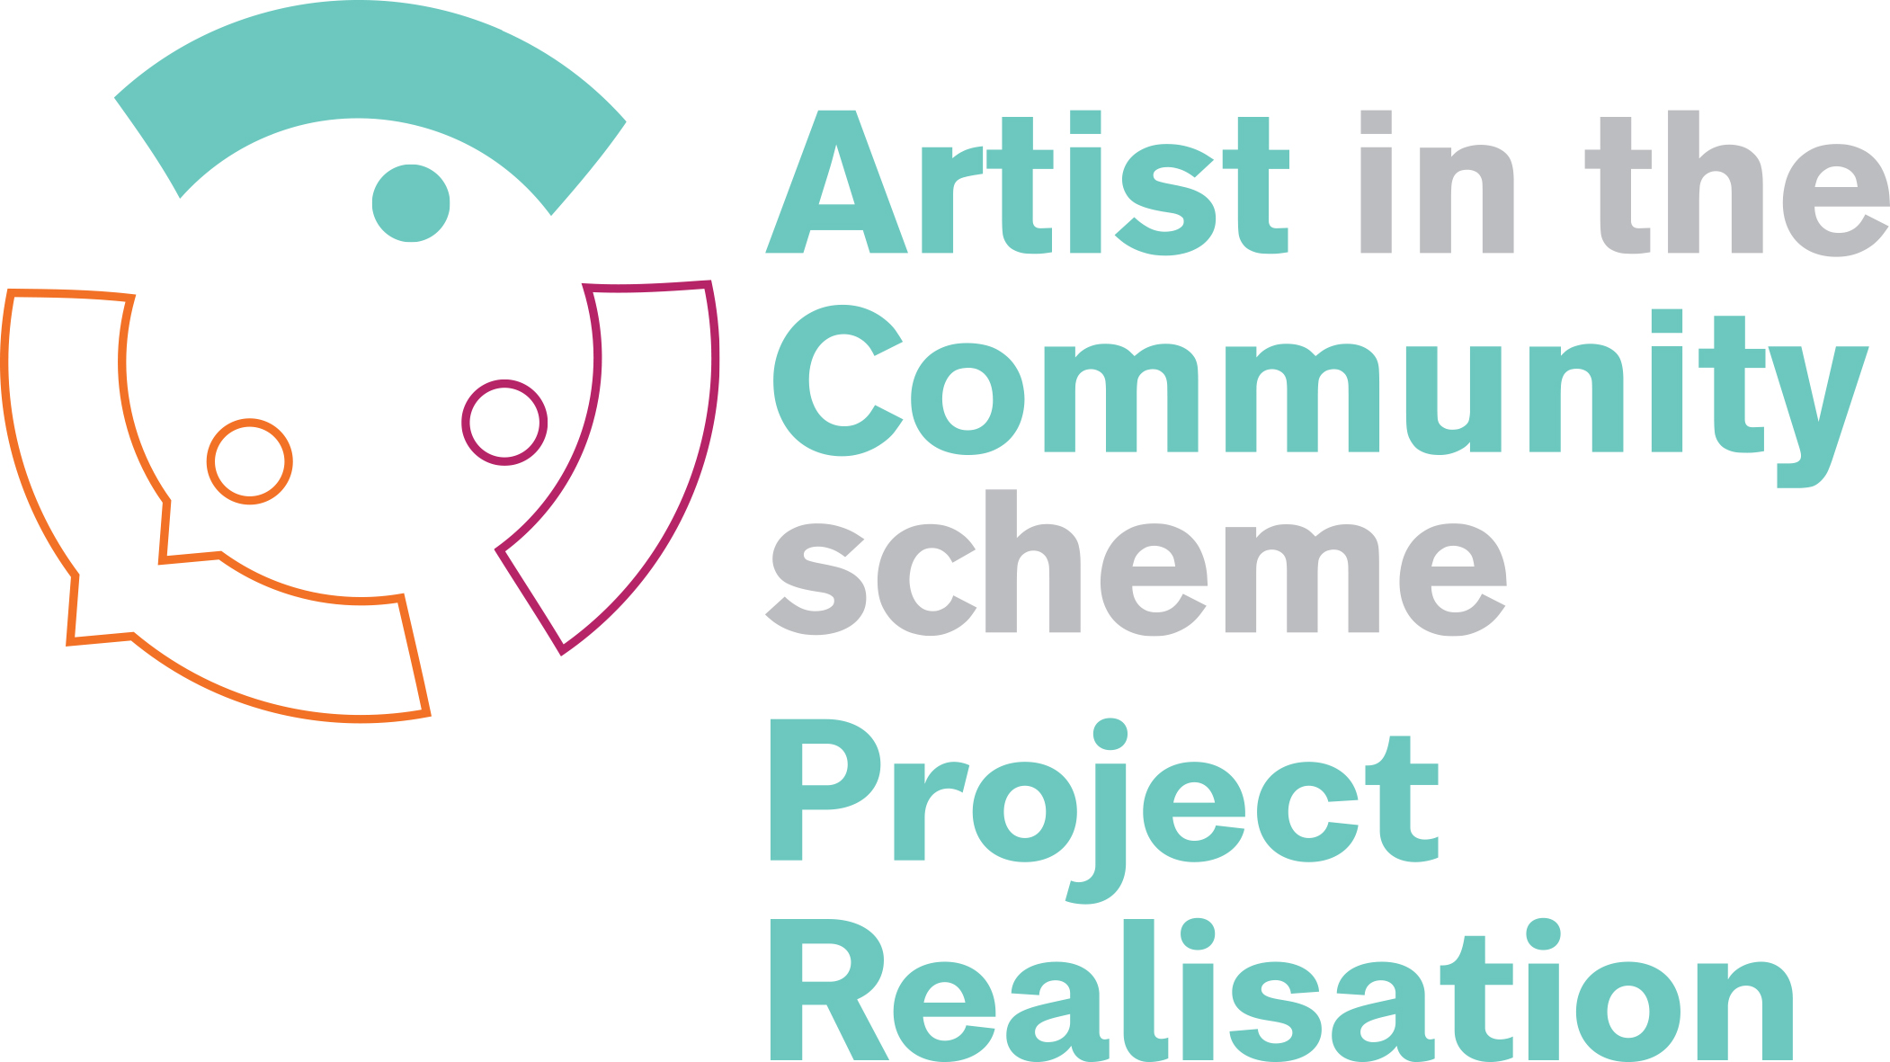
Project Realisation Award
The Project Realisation Award aims to support proposals from communities of place or interest or both, who want to collaborate artistically with an artist or artists. These communities must be made up of non-arts professionals.
This award is open to communities and groups (or their representative organisations) to undertake an arts project in a community setting or social context. Projects are expected to be ambitious, innovative and visionary.
Communities are the applicants
In this strand, the community is the applicant. However, the community and the artist must consult so that both parties are involved in deciding how the project will be carried out. The community or group must “own the art project” at every stage.
The community leads on this application and is responsible for submitting the application form. However, the proposal is written together and in consultation. There are sections in the application form for the community to complete and a section for the artist to complete.
Timeframe and amount available
The project should have a timeframe of 8 to 12 months.
Funding range: The maximum award is €15,000.


Evaluation methods are also very important for the Project Realisation strand. These cover the progress, outcomes and outputs of the project. See Section 4.7 for more information about monitoring and evaluation of the Project Realisation award.

Who is eligible to apply for the AIC Scheme?
Applicants must be resident in the Republic of Ireland
The AIC Scheme is open to:
- Professional artists
- Community groups
- Community organisations
Generally, you must be resident in the Republic of Ireland. However, we may accept applications from outside the Republic of Ireland if your proposal would benefit the arts in the Republic of Ireland. In this case, you must detail in your application form how it would do so.
Eligibility for the Recent Graduate, Research & Development Award (with mentoring)
We consider recent graduate artists to be people of any age who:
- have graduated from an undergraduate degree programme in the arts in the past three years
- are interested in developing or exploring or are establishing a professional career in collaborative arts practice
This award specifically targets emerging artists who have completed their undergraduate degree and who are not in postgraduate studies at the time an AIC award is offered.

Equitable opportunity
The Arts Council and Create (the national development agency for collaborative arts) particularly welcome new applicants who represent the diversity of Irish society. We encourage applications from all areas of the community regardless of your:
- gender  - sexual orientation  - civil or family status  - religion | - age  - disability  - race or membership of the Traveller Community  - socio-economic background
This includes but is not limited to any of the characteristics outlined above. We also welcome initiatives that deliver equitable opportunities or outcomes for those involved. For more details, see the Equality, Diversity and Inclusion policy on the Arts Council website.

Who is the applicant?
The applicant is the individual artist or organisation or community that will receive any award offered and who will be required to accept the terms and conditions of that award.
The lead applicant in the Research and Development Award is the artist who plans to work collaboratively with a community.
The lead applicant in the Project Realisation Award is the community group(s) who apply to work with an artist.
We pay awards into applicant’s bank account
We will pay any award we offer only into a bank account held in the name of the applicant.

Who may not apply?
Those with pre-planned projects that were not developed with the community
You are not eligible to apply if you are looking for people to take part in a pre-planned arts project that has not been co-created with the community. To be eligible, you must intend to plan and develop a project from beginning to end in collaboration with a specific community group or groups.
Those whose main goal is health and well-being
You will not be eligible for an award if you are working on projects where health and well-being is the primary goal or outcome.
In the area of Arts and Health, the Arts Council only supports proposals that have artistic goals and outcomes alongside those related to health and well-being.
Those whose main target group is children and young people
Proposals where the main target group is children or young people will not be eligible. However, you may be eligible if there is at least an equal focus on intergenerational practice. See the Arts Council website for supports for young people and children.
Those who are in undergraduate or postgraduate education
Research & Development Awards are not open to individuals:
- currently in undergraduate (including foundation courses) or postgraduate education, or
- who will be during the period for which this award is offered
However, a postgraduate student may apply for a Project Realisation Award. On the Application Form, the applicant must provide the name of the course and outline how the proposed project relates to their studies.
Those who submit a proposal with no artistic collaboration
Proposals from artists or arts organisations that do not include artistic collaboration with non-arts professionals will not be eligible for an award.
Organisations currently in receipt of funding under Arts Council grant programmes (Strategic Funding, Arts Centre Funding and Partnership Funding)
However applicants may name such organisations as partners.
Organisations and individuals in receipt of Arts Grant Funding
(unless otherwise specifically advised by the Arts Council or Create)
However applicants may name such organisations as partners.
Ineligible Institutions
National Cultural Institutions (CNCI) (or their Council members) directly funded by the Department of Culture, Communications and Sport are not eligible for these awards.
If your application is deemed ineligible, we will not assess it. However, you are entitled to reapply with the same proposal in future funding rounds if you make changes to ensure you meet the eligibility requirements. You can contact us (info@create-ireland.ie/ 014736600) for an advisory session if you choose to do this.

What funding may you apply for?
In this section, we tell you about:
- Funding for Research & Development Awards
- Funding for Project Realisation Awards
- How much funding you should apply for
- Funding for access costs for artists or participants with disabilities
Funding for Research & Development Awards
This award funds research and development work lasting up to 6 months. You can also apply for access costs.
Option 1: Research & Development Award (without mentoring)
Maximum award possible: €3,500

Option 2: Research & Development Award (with mentoring)
Maximum award possible: €4,500
This breaks down as €3,500 for the Research and Development and €1,000 for the artist’s mentor

Recent Graduate, Research & Development Award (with mentoring)
Maximum award possible: €5,500
This breaks down as €3,500 for the Research and Development and €1,000 for the recent graduate’s mentor. A recent graduate can seek up to €1,000 additional funding. This funding is to support the development of their practice.
The recent graduate can use the additional funding to cover additional support needs such as:
- developing relationships with partners (we do not expect you to do additional contact hours in the community)
- more desk research (study of documents and other projects)
- bringing in additional expertise
Additional expertise may include:
    - a journalist
    - community development worker
    - healthcare worker
- someone whose expertise will enhance the artist’s practice and the potential project development
Funding for Project Realisation Awards
This award will be for projects lasting from 8 months up to 12 months. The maximum award is €15,000. You can also apply for access costs.
Project Realisation Award
Maximum award possible: €15,000

How much funding you should apply for
We recommend that you apply for the full amount available for each award. To decide how much funding you should apply for, you will have to first work out your proposal’s budget. Please see the Budget Template available on the Create website, for additional information on how to create your budget, and what we expect in the application form.

Access costs for artists or participants with disabilities
The Arts Council is committed to making funding programmes and the work they fund accessible to everyone.
The Arts Council takes the description of disability from Article 1 of the UN Convention on the Rights of Persons with Disabilities, which states:
‘Persons with disabilities include those who have long term physical, mental, intellectual or sensory impairments which in interaction with various barriers may hinder their full and effective participation in society on an equal basis with others.’

You can include access costs within your application. There are two types that you can apply for.

Participant or personal access costs
These costs should help make it easier for artists or participants with disabilities to take part in your project. For example:
- you
- the main artists, individuals, groups, or organisations involved in your proposal
- partners or collaborators
- production staff
- core staff or key administrative personnel
Examples of support are, but not limited, to the following:
- an ISL interpreter
- services of an access support worker
You can apply for participant or personal access costs separately, on top of the maximum award amount.
Costs for making your work accessible to others – public access costs
We want to make sure that more people enjoy high-quality arts experiences and that everyone can access and enjoy the work we fund.
Public access costs are costs for making your work accessible to people with disabilities and should be considered a normal part of your work.
Example of access costs to make your work accessible to your audience may be:
- having an Irish Sign Language (ISL) interpreter for your event or performance
- using an audio description service
- making your website compatible with screen readers
- producing exhibition materials in other formats like in Braille or audio
Public access costs must be included within the maximum award amount and are considered a standard part of your project budget.
What if the disability access costs provided is less than I requested?
If we offer you less money than you asked for, we will discuss with you how to adjust your plans to fit the smaller budget.
How to apply for disability access costs
We need to understand why you are applying for disability access costs and how they meet the needs of your participants or your audience. You must upload a document listing these costs with your supporting material. See Section 2.8 to read more about what documents you must include to support your request for disability access costs.

What you may and may not apply for
You may only apply for one award in the same funding round. This means that:
- An applicant cannot apply for a Research & Development Award and a Project Realisation Award for the same project idea in the same round
- An individual artist cannot be named in more than one application in the same round. However, they can be named as a mentor in a second application.

The AIC Scheme awards will not fund the following:
An existing project or programme of work
Non-arts projects or programmes of work
Ongoing core costs
Major capital purchases (Examples include buying equipment, laptops, cameras, and so on. These are not covered by awards.)
- Projects already receiving other Arts Council funding
- Non-collaborative work
- Activities or costs that do not fit the purpose of the award
- Activities that are more suitable to another award funded by the Arts Council or other agencies, including but not limited to:
    - Culture Ireland
    - Fís Éireann/Screen Ireland (formerly known as Irish Film Board)
    - Design & Crafts Council
    - National Youth Council
- Activities that have already taken place or will be completed before a decision is made on your application
- Activities that are undertaken for a charity fundraising, competition, or profit-making purpose
- Activities that focus primarily on art therapy as opposed to artistic outcomes
- Activities that have already been assessed by the Arts Council or AIC Scheme unless:
    - you show that you have significantly developed the proposal since previously applying
    - the Council has specifically advised you to redirect your application to this award (please bear in mind that such advice does not mean your application will be successful).
- Projects where the lead artist is not paid for their involvement (if you have any questions please contact Create)
- Activities where the artform or arts practice is not provided for by the AIC award. See Section 2 to learn more about what artforms are funded by the Arts Council.

Eligibility criteria
We will only consider your application if:
- you fulfil the eligibility requirements (Section 2.1)
- your application and supporting documentation is received by the deadline
- you submitted your application form and supporting material online
We do not accept email or paper applications. We accept applications from the online application form only.

Supporting material
Guide to supporting material you must submit with your application
You must submit the required supporting material, so that we can accept your application. You upload this material with your application form. Supporting material helps the person assessing your application to get a clearer understanding of your proposal.

The most common reason for applications to be deemed ineligible is because the applicant has not submitted their supporting material.
All applicants must submit the following:
Detailed up-to-date CVs
You must submit a CV for all the artists involved in the proposed project. This should be three pages long at most.
Examples of previous work
You must submit examples of previous work that show relevance to the proposed project. But only send us at most:
- 10 images
- 3 texts
- 3 videos
- 3 audio samples
You should include a note explaining the relevance of each example. See Section 3.1 for further details on submitting examples of previous work.
Evidence of financial support or sponsorship
You must show us evidence of any financial support or sponsorship identified in the project budget. For example:
- A memorandum of understanding
- A letter of offer
- A statement of support
Funding for access requirements
We need to understand why you are applying for disability access costs and how they meet the needs of your participants or your audience. You must upload a document listing these costs with your supporting material. You can use this optional Disability Access Costs template to do so. You must also show the costs in two separate lines in your budget template.
- A line for personal disability access costs (see budget template – line 6.2)
- A line for audience disability access costs (see budget template – line 5)
Evidence of community support
If you are applying for a Research & Development Award, you must include evidence of support from the community. For example, a letter showing support or interest in being part of the Research & Development Award and potential future project.
Letters of support or expressions of interest should come from the people or groups who will actively collaborate with the artist. These letters help show genuine community interest and involvement.
What to include:
Be specific. Each letter should clearly describe:
- Who is supporting the project (include names or roles, and how many people are involved).
- Why they are interested in working with the artist.
- What their ambitions or hopes are for the artistic collaboration (e.g. skills exchange, community outcomes, creative goals).
If the letter is from a lead or support organisation:
- Focus on the community’s support for the project, not just the organisation’s desire to partner.
- Show that the organisation represents and reflects genuine community interest and endorsement.
What to include in the letter:
- Clearly outline how the artist and community have engaged so far.
- Be specific about:
  - How many people have been involved or consulted.
  - Who they are (e.g. community members, elders, youth, local groups).
  - Why they are interested in the artist’s work and the research or development phase.
- Their ambitions for the artistic collaboration- how this collaboration will grow or benefit the community
Mentor information
If you are applying for Research & Development Award with mentoring, you must include:
- a CV or biography of any proposed mentor. CVs or biographies should be three pages long at most
- a schedule of meetings with the proposed mentor
- a letter from the mentor, including an agreement that the mentor will be paid €1,000 and outlining the fee breakdown
The mentor must be an arts professional.
Additional material required in certain circumstances
Services for children and young people
The Arts Council requires all individuals and organisations providing services to children and young people under the age of 18 to have suitable child-protection policies and procedures. This includes services like cultural, recreational or educational activities.
When you apply, you must say whether your project involves children or young people under 18. If you answer ‘Yes’ and your application is successful, you must meet certain conditions. This includes confirming that you have appropriate child-protection policies and procedures in place and being able to show evidence of them. Please see https://www.tusla.ie/ for more information.
Working with vulnerable people
If your proposal involves working with vulnerable people and is successful, you will need to meet certain conditions. The HSE considers a Vulnerable Person as an adult who may be restricted in capacity to guard himself / herself against harm or exploitation or to report such harm or exploitation.
You must acknowledge that you follow the ‘National Policy & Procedures on Safeguarding Vulnerable Persons at Risk of Abuse’.
Working with animals
If your proposal involves working with animals and is successful, as a condition of funding you must provide a copy of your Animal Welfare Protection Policies and Procedures.
Optional supporting material
In addition to the required supporting material listed above, you may submit any other material you consider relevant to your application.

Making your online application
You must use the online form to submit your application. You will find this form on the Create website. If the online form is not accessible for you, please contact Create. We will do everything we reasonably can to help you if you:
- email info@create-ireland.ie, or
- call us on (01) 473 6600
Before you start filling in your application, please read the questions first. Then prepare your answers using the “reference only” application form which is available on the awards page.
It helps to read this form and know what to expect before you fill in the real form online.
When you start filling in the online form, you can save your application part-way through and access it again within 30 days, but remember that you must submit it in full by the deadline.
Make sure you are completing the correct form
There are two application forms, one for each award. Each form is clearly labelled using one of the logos below. Please check to make sure you are on the right form.
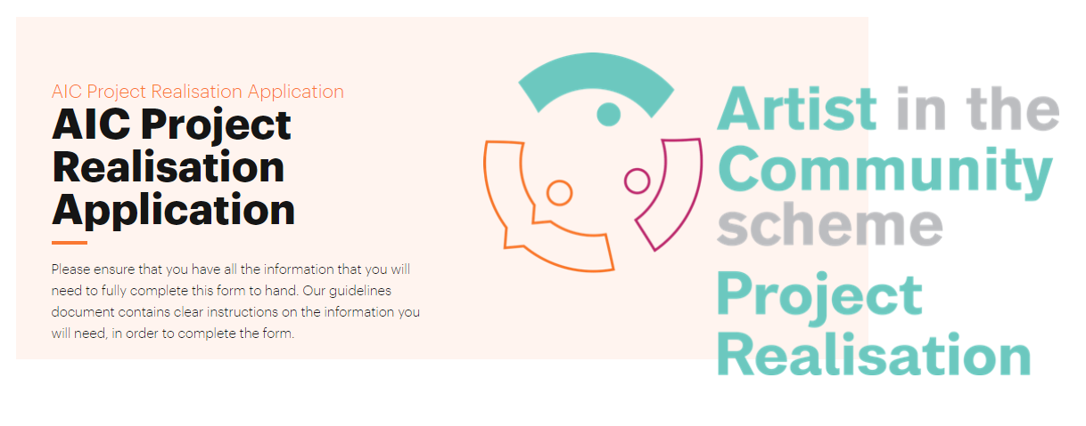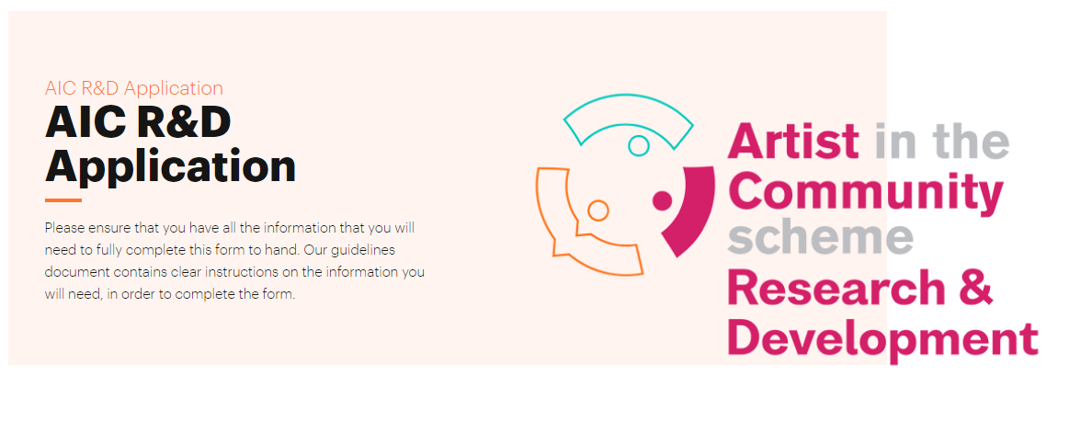
Use the previous and next buttons to navigate through the form. However, please note that you cannot move through the form without completing all compulsory (required) questions. These questions are marked with a red star.

You may choose to “save and continue later” if you wish to revisit your online application. To do so, click on the “save and continue later” button. This will bring you to a page with a link. You can also choose to email this link to yourself, using the box provided.
Once you have completed the email address and pressed “submit” you will see a screen that confirms that your progress has been sent to your email address.
You can access your application form using the link sent to your email address (please make sure to check your spam or junk folders). You must complete the form within 30 days of receiving the link, and before the application closing date.

Prepare your supporting material
You must include supporting material with your application. Please see Section 2.8. You must submit all such supporting material online. So, if necessary, you may need to scan or save material in electronic format.
Acceptable file formats
The following table lists file formats that are acceptable as part of an application:
File type | File extension
Text files | .rtf/.doc/.docx/.txt
Spreadsheets | .xls/.xlsx
Adobe Acrobat Reader files | .pdf
For convenience, gather all the files you need into a single folder on your computer.

Submitting video and audio links
You may not load audio or video files directly to the application form. If you wish to include audio or video in your application, you may provide links to material hosted on Soundcloud, YouTube or Vimeo.
To do this, copy the URL (the full address of where your material is hosted, for example, on YouTube) into a Microsoft Word or OpenOffice Writer document. Upload it as a ‘weblink-supporting document’.
We will only view links to the three hosting sites listed above.
If you do not wish material you upload for your application to be publicly viewable, you can flag your video as ‘unlisted’ or password protected in its settings. Make sure that you also give us the password.
Please note, standalone supporting materials like CVs and letters of support must be uploaded as separate documents with your application. We will not accept links to file-sharing sites like Google Drive.
Naming files appropriately
Give all files that you intend to upload filenames that make it clear what they contain or represent. For example, it should be clear from the filename whether the document is a CV, a sample text or a review of previous work. Please submit supporting documents in separate, appropriately named files.
Good filenames for an applicant called Jack Russell | JackRussell soundcloud link.doc  JackRussell support letters.pdf  JackRussell Child Protection Policy.doc  JackRussell youtube link.doc
The total combined limit for all supporting material uploaded with a single application is
128 MB. The maximum size for each file is 16 MB. Files larger than this will not load and you cannot include them in your application.
To load supporting materials in the online form, simply drag and drop files into the box provided, or choose files individually.

The image below shows the successful loading of three files. If you need to remove one or more, you can click on the red “X” or bin icon.
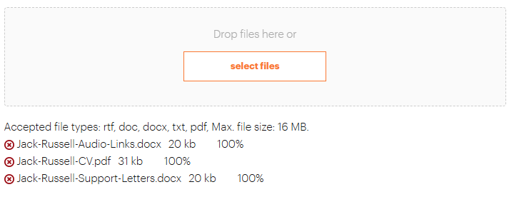

Processing and assessment of applications

Overview
Create manages the AIC Scheme on behalf of the Arts Council. We support the panel assessment and decision-making process. We keep applicants informed about these processes in line with our procedures. Our aim is to make sure that the system for making awards is fair and transparent.

The assessment process
We process all AIC Scheme applications we receive as follows:
1 | We acknowledge your application on the online portal
2 | - We check that your application is eligible  - All eligible applications then progress to the assessment stage
3 | - A peer panel reviews all applications and associated materials  - They score the applications and make decisions
4 | We email decisions to applicants
5 | If you would like feedback on your application, you must ask for this within 2 weeks of being told the panel’s decision
6 | Decisions are noted by Create and the Arts Council
Time frame before outcome known – up to 7 weeks
Create tries to process applications as quickly as possible. The volume of applications and the rigorous assessment process mean that it may take up to seven weeks from the closing date to make decisions.

Criteria for assessing all applications
It is vital to read the assessment criteria before you apply, as this section explains how the panel will evaluate your application.
All applications are assessed in a competitive context. This means there are more applications than available awards. Panellists review each application based on the information and materials you submit.
We assess applications on how well they meet the objective and priorities of the award (see Section 1.2).
In particular, we assess the applications to make sure the processes or methods will be collaborative. For Project Realisation Awards, participants should have a direct influence on the process and product, from start to finish.

Artistic merit
The assessment of artistic merit focuses on the applicant and on those involved in the project, as well as the nature of the proposed arts activity and includes consideration of:
Quality of the idea
And the proposed –
- research aims (Research & Development only)
- arts activity (Project Realisation only)
Track record
We assess the track record of the applicant, and the artistic personnel involved in the project as shown in the:
- CVs
- other supporting materials you submit
Potential
We assess the potential of the applicant, and the artistic personnel based on information in the application form and supporting material
How artist has developed professionally
We assess the professional development of the artist as shown in the application
Ambition, originality and competency
We assess the proposal for the ambition, originality and competency demonstrated in the proposal
Innovation, experimentation and collaboration
We assess how the application demonstrates innovation, experimentation and collaboration
Artform
The artform/arts practice context in which the activity is proposed

Outcomes and Outputs
We will assess:
- Anticipated outcomes of research – (Research & Development only). Outcomes refer to the effects, changes, or impact that result from the artistic process
- Artistic outcomes and artistic outputs - (Project Realisation only). The process must result in an artistic project or event
Example of outcomes could include:
- improved relationship between the artist and the community
- increased visibility of underrepresented voices
- influence on policy or public discourse
- the community having ownership of the project
Example of outputs could include:
- exhibition
- performance
- publication
Feasibility
When we assess feasibility, we consider how well the applicant shows they can deliver the proposed activity. We take into consideration:
Track record
We consider the track record of personnel involved in managing, administering and delivering the project
Fair pay and conditions
We look at how you are providing fair conditions and remuneration for all artists involved
Involvement with partners
We consider the level of involvement or commitment of identified project partners
Budget
We consider:
- Your proposed budget
- Your sources of income and funding
- how the award will be used
We encourage applicants to source funding from other partners or in other ways
Resources
We consider the availability to you and the access you have to other resources including in-kind support
Timescale
We look at your proposed timetable or schedule
Evaluation methods (Project Realisation only)
We look at your evaluation methods. This means how you will document and assess the progress and outcomes of the project
Criteria for assessment of mentoring
An application that includes mentoring must clearly show:
- the specific mentoring needs you have identified
- how the mentorship will help develop the artist’s practice
- why the chosen mentor is a good match for the artist’s needs

Peer Assessment Panels
The purpose of peer-panel meetings is to allow for a diversity of expert views to inform the decision-making process. These panels usually include at least three external assessors who have relevant expertise in a specific artform or arts practice.
Create and the Arts Council agree in advance on potential panel members. This can include people who have appropriate experience, local and social or community knowledge and are:
- arts practitioners
- arts managers and producers, or
- arts development officers
Each panel meeting is usually led by a representative from the Arts Council who acts as non-voting chair. They chair the discussion and make sure the process is followed fairly.
Panellists have access to all applications and associated materials before the day of the meeting. At the meeting they review, discuss and score shortlisted applications. Following this, applications are ranked by score.
Scoring process
The panel is asked to score applications according to the following system:
A – Must Fund (10 points)
The application has fully met the criteria for the award and merits funding to the full amount requested (if possible).
B – Should Fund (8 points)
The application has met the criteria to a sufficient extent to merit funding if the funding scheme has enough budget.
C – Could Fund (5 points)
The application has met the criteria, but to a lesser extent than other applications.
D – Not a Priority (2 points)
The application has not met the criteria well enough to merit funding.
Declaration of interest
We have rules in place to make sure decisions are fair. A panel member must declare an interest where they have a close personal or professional link with the applicant or are linked in any way with the application.
An ‘interest’ is either pecuniary (financial) or non-pecuniary (non-financial). For example, pecuniary interest might be formal or informal business partnerships. Non-pecuniary interests would be people like family members or personal partnerships.
If a panel member has an interest in the applicant, they must declare this as soon as they become aware of it. This may be when they are approached to sit on the panel (if the ‘interest’ is known at that stage) or when they receive the list of applicants.
Where an interest is declared, the panel member will not receive papers relating to that applicant. They must leave the room when the specific application is being reviewed. Where this situation arises, the chair will vote instead of the panel member.
Sometimes, a panel member may not realise that a conflict of interest exists until they receive and review the panel papers. In such cases, the panel member must alert Create as soon as they become aware that a conflict may exist.
If the nominated panel chair has a conflict of interest, they must declare it in writing as soon as they are aware of it – before the meeting. In that case, a senior Arts Council staff member who is not involved in the application will chair the discussion for that particular application.

Outcome of applications
We email all applicants about the outcome of their application. If your application is successful, we will send you a letter of offer detailing:
- the amount of funding you have been awarded
- the terms and conditions of the award
- how to draw down your award
This is a competitive award and demand for funding always exceeds the available resources. Eligibility and compliance with application procedures alone do not guarantee that you will receive an award. If your application is not successful, you can request feedback from Create within two weeks.
If the Arts Council feels that the proposed activity would have been more suited to a different award programme, they will write to tell you so.
Unsuccessful applicants may only apply for another Arts Council or AIC Scheme award to undertake the same activity if they show that they have significantly developed the proposal since previously applying.
If your application is ruled ineligible, we will not assess it. You will be permitted to apply again with the same proposal in future funding rounds. If you plan to reapply, we recommend that you ask for feedback from Create and put the recommendations from that feedback in place. You will still need to make sure that you meet the eligibility requirements.
Appeals
Applicants may appeal against a funding decision if they believe there was an infringement or unfair application of, or a deviation from the published procedures. You may make a written appeal to the Arts Council, clearly stating the grounds for the appeal, and following the process outlined on its website.

Documentation
When you receive funding for a project under the AIC Scheme, you must consider the following points. You need to do this as we will expect you to send us a written report with a visual record of the main stages or elements of the project.
High-quality documentation that needs to be gathered and kept
You must keep a high-quality visual record (photography, video or film recordings) of the main stages or elements of activities achieved under the AIC Scheme. This is especially important for Project Realisation Awards. High-quality visual documentation is important because it serves as a valuable record for the work. It may be used:
- as evidence of how you have used funding
- to share parts of your work with a wider audience, especially works that do not result in permanent, physical artwork. For example, performance or temporary installation artworks
- in future publications
- in case studies
- as an important resource to artists
For example, this documentation may track work from the proposal, through project development to outputs like installation and performance.
Due to the nature of the projects we fund, final outputs may not be permanent. They may be temporary, site specific, or specific to a moment in time.
The lead artist usually handles project documentation. However, when they involve both artists and community members in the process it can help tell the story of intersecting ideas and different perspectives. The ideas and viewpoints do not all have to fully align. Documentation is an important part of activities achieved under the AIC Scheme.
You should consider the cost of engaging a professional or commissioned artist to carry out documentation for you. If you decide to do this, you should include the cost of documenting your activities in your budget.

Reporting, Monitoring and evaluation
Reporting
If you are successful in receiving funding, you will need to submit a report at the end of the funding period. You will receive further information about reporting requirements upon receiving your award.
Monitoring and Evaluation
The information below offers tips and things to keep in mind when thinking about monitoring and evaluation:
Why you need to monitor and evaluate your project
- Monitoring and evaluation are valuable tools for artists and communities to begin early in a project. They help to document the project’s development as it unfolds and support honest, reflective reporting throughout
- Evaluation is particularly important as it can strengthen artistic practice by encouraging learning and critical reflection. It also supports artists and communities to adapt and grow by learning from challenges and experiences
- Monitoring and evaluating your project can also help Create and the Arts Council to better understand the impact of collaborative socially engaged art
- It makes the creative process more visible especially for those who aren’t directly involved in the project
- It also gives us better information because it includes different voices and perspectives
- It encourages reflection and learning for the artist and community group. This can help to shape future work
- It helps to inform Create of the general landscape in the collaborative arts, enabling us to improve how we support and approach future projects

Consider the phases of the project
Collaborative art is a process-based practice; therefore, it is important to consider how the project will be monitored and evaluated throughout its lifetime.
When filling out the Monitoring and Evaluation section of your application, please consider three phases of collaborative socially engaged art and how they relate to each other. These phases include Pre-production, Production, and Post-Production.
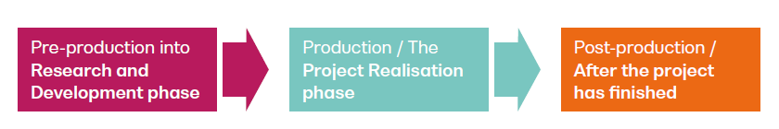
Visual of the phases for collaborative socially engaged art
Considerations and actions throughout the project
Please reflect on the following throughout the project, and as you evaluate your work:
Defining the identity of the project
This includes the values, beliefs and purpose of the project. What is the project about or responding to?
Relationships
Please consider the nature and development of the various relationships formed throughout the project between collaborators, community members and mentors.
- How did these relationships begin?
- How have these relationships grown, changed, improved, weakened?
- What kind of organisational structures developed and why? Are these structures:
    - hierarchical
    - bottom-up
    - democratic?
- How are responsibilities distributed among collaborators?

Traceability and flexibility
Consider the traceability and flexibility of the different parts of the projects. For example, things like:
- how did it change or evolve from the anticipated project outcome to its conclusion?
- how did any perceived constraints differ from constraints that arose?
- did you adapt or change your methods in response?
Measure the impact of your project
We use the term ‘impact’ to describe all the different ways the project may have affected those who collaborated. This includes artists and any organisations or institutions. Impacts are things you can measure. For example, they could include numbers such as number of people who took part and satisfaction ratings. Impacts also describe the value of the project to others and what effects it may have generated. For example:
- who it impacted?
- how it impacted them?
- how do the community members value this impact?
- is this value different to that used by the practitioners?
We ask you to consider the balance of qualitative (quality of the project) and quantitative (tangible results that can be measured) aspects of the project.
Reflect multiple voices
Please make sure that your evaluation and monitoring reflect the multiple voices involved in a project. For example, you may want to think about how you will monitor participants’ responses at different stages of the project and overall.
This is like reporting and we encourage honest, open and reflective feedback.

Methods of Evaluation
Quantitative | Qualitative
- Assumed to be objective  - Focus on numbers  - Describes who, what, where, when  - Seeks to measure. | - Can be more subjective  - Focus on narrative  - Describes why, how  - Seeks to understand  - Requires critical reflection
Tools for evaluation
Below is a selection of tools that can support the evaluation of collaborative socially engaged arts projects, helping you to reflect on the process, gather feedback, and demonstrate impact:
- Reflective Journals
- Participant feedback and questionnaires/ surveys
- Observation/participation methods
- Interviews, group discussions, focus groups
- Visual Timelines or Project Mapping
- Thematic Analysis
- Visual methodologies, e.g. diagrams

Glossary
Artist
A person who is actively pursuing a career as an artist in any art form, and who considers their arts work as their main profession or career. This applies even if their work in the arts is not their main source of income or they have other employment.
Collaborative arts
Create defines collaborative arts as: Collaborative arts practice involves artists and communities working closely together, often over extended periods of time, to make art. Artists must aim to plan and develop a project from its earliest stages through to completion in collaboration with a specific group or groups, rather than seeking participants to join a pre-planned arts project. See a full definition of ‘Collaborative arts’ on the Create website.
Community
In the Artist in the Community Scheme, we mean community in the broadest sense. A community can be defined as a group of people brought together by a shared purpose. This may include communities of place (people brought together by a shared place, for example where they live, their place of work, etc) or communities united by a specific interest, or both.
Outcome
Outcomes are the short-to-medium-term changes that are the result of activities, such as increased skills or heightened confidence.
Output
The immediate results from activities: examples of outputs are an exhibition or event.
Qualitative
Qualitative information is descriptive and is usually written or expressed in other forms such as images or sound. It is often provided in response to questions such as ‘how’ or ’why’. For example, how relationships between community and artist have developed.
Quantitative
Quantitative information is numerical and is usually expressed in numbers and quantities. For example, how many community members were involved and for how long.

Data protection

Privacy statement
We are committed to clear and transparent decision-making.
Create is responsible for keeping safe the personal data of applicants to the AIC Scheme. We are committed to protecting privacy rights when we process the personal data that we collect. We will treat any personal information sought or volunteered with the highest standards of security and confidentiality. We will do this in line with data protection law and regulation.

Data management
We use information we collect through the application process only so we can manage the scheme. We will not disclose (share) personal data to any third party without consent. Where we must comply with statutory requirements or where a third party is acting on behalf of Create and with our consent, we may disclose information for a research purpose.
If the Arts Council intends to process data we provide, all personal data will be anonymised (names will be removed). We keep application forms and supporting materials in line with our Data Protection Policy.

