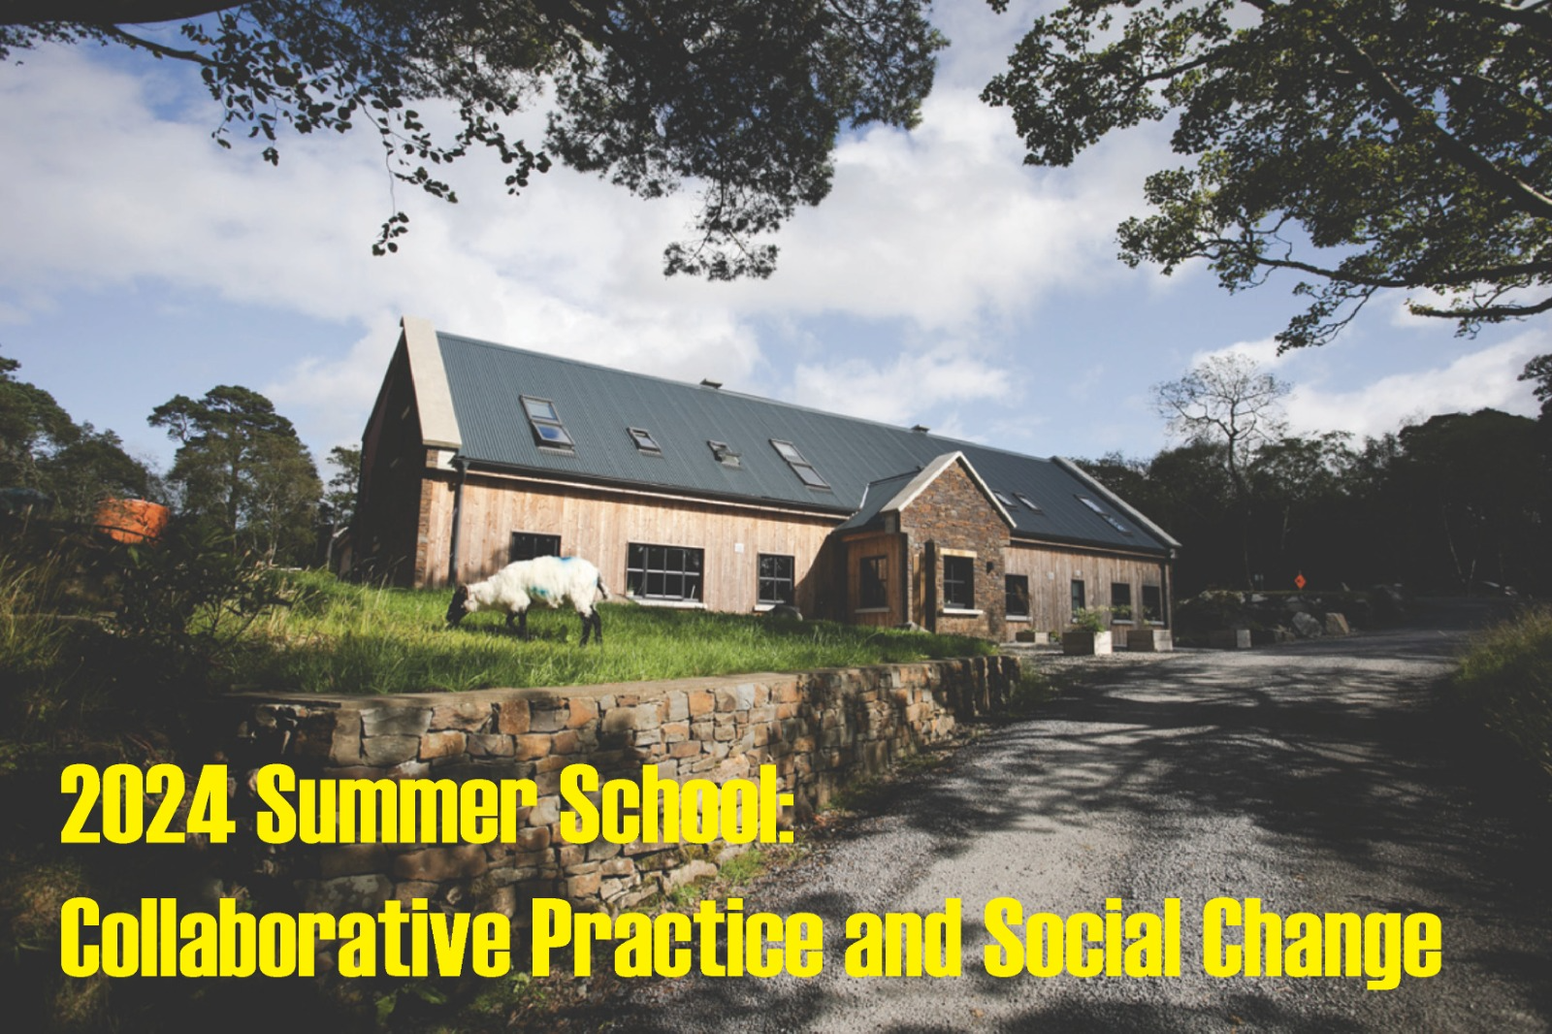

Summer School on Collaborative Practice and Social Change
Create and Counterpoints Arts are pleased to announce the 2024 Summer School on Collaborative Practice and Social Change for up to 14 artists and cultural activists. The Summer School will take place over six days: 10 – 15 June 2024, at Killary Lodge, Co Galway.
The deadline for submission is 5pm, Monday 15 April 2024.
In a world increasingly shaped by the erosion of democracy and public trust, together with the impact of global displacement, the Summer School on Collaborative Practice and Social Change invites socially engaged artists and cultural activists to take part in a unique and timely learning space.
The Summer School will focus on the central role that grassroots communities play in the strengthening of local and trans-local democratic practices. The School is shaped by a belief in the power of cooperative and transdisciplinary ‘thinking through doing’; in the transformative potential of projects that can facilitate new political imaginaries from the ground-up; in public sphere projects that are co-produced via creative alliances between artists, activists and communities of place and interest.
Now in its seventh year, the Summer School will expand its focus on the importance of countering disinformation and false narratives through mobilisation of the place-based sensibilities of socially engaged arts practice; combining participation and collaboration across diverse communities, with the storytelling and reporting skills of investigative journalism and digital activism.
We encourage applications from artists and cultural activists who are involved or are interested in social change and movement organising in relation to structures of inequality, further inviting intersectional practices shaped by a range of mediums including music, film, theatre, creative writing, journalism, architecture and design and visual arts, amongst others.
The six-day format of the Summer School is designed as an immersive incubator inviting participants to work on an imagined cooperative commission, alongside skills training workshops, comparative case studies, peer-to-peer reflection and one-to-one mentoring.
If you are interested to participate in the 2024 Summer School on Collaborative Practice and Social Change, please submit a short Expression of Interest (EOI) giving us a sense of your socially engaged practice and/or cultural activism to date; and what you wish to bring to the cooperative values and ethos of the School (see EOI guidelines for more information).
The Summer School is delivered in partnership by Create and Counterpoints Arts with funding support from The Arts Council of Ireland and the Rowan Trust.
Summer School Director: Dr Áine O’Brien – Curator of Learning and Research and Co-Founder, Counterpoints
Summer School Producer: Áine Crowley – Programme Manager, Arts and Engagement, Create

Visiting artists and facilitators:

Ismail Einashe, Investigative Journalist and Cultural Activist
Khaled Barakeh, Socially Engaged Artist and Founder/Director, co culture
Kate O’Shea, Socially Engaged Artist and Cultural Activist

About Killary Lodge Co. Galway
Participants will stay in Killary, Co. Galway - a country lodge nestled among mature native trees just 250m from the waters of Killary Fjord, in the heart of Ireland's stunning Wild Atlantic Way. The house has 10 bedrooms and 12 bathrooms. Please note that participants must be willing to share bedrooms, however this will be accommodated in consultation with you. The house is wheelchair accessible: it includes a lift to the first floor and ramps to access outdoor spaces. Please contact us if you have any questions or need clarification. The residential will include full board, travel and an appropriate participant allowance to cover additional costs incurred.
Explore Killary Lodge.
For enquiries contact: support[at]create-ireland.ie

Making an Expression of Interest
See Guidelines for Summer School on Collaborative Practice and Social Change

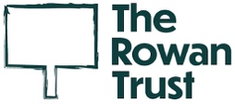
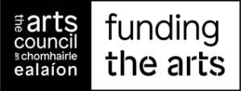
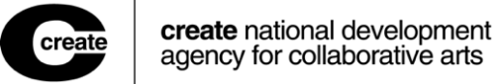
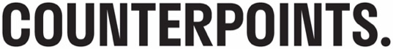

Guidelines: Summer School on Collaborative Practice and Social Change

Who should apply?
- Artists /cultural activists based in the Republic of Ireland
- Artists /cultural activists who are involved or are interested in the intersection of socially engaged arts/ social change /movement organising
- Artists/cultural activists who are interested in exploring the themes and questions posed by the 2024 Summer School in relation to their individual and shared practice

Who is not eligible?
- Undergraduate students are ineligible to apply

3. How to apply and deadlines
All applications must be made using the online form, which you will find on the Create website. (If for any reason you cannot use the online form and need to submit in a different format, please contact us via phone on 01 473 6600 or email info@create-ireland.ie). Also see section 4. Applicant Supports for more details on access supports.

Step 1: Expression of interest
Deadline: 5pm, Monday 15 April 2024
You are invited to submit:
- An expression of interest - max 3 A4 pages (see below for more detail on what to include in the EOI)
- A CV of max 2 A4 pages, to give a sense of previous projects
- 1-2 short descriptions of socially engaged practice projects and/or cultural activism work to date (please include any examples, ie., of links or samples of your work if relevant).

Expression of interest - guidance note

The Summer School offers an opportunity for exchange and networking - what is it you wish to explore and learn alongside other participants?

How and why is the collaborative focus of the School – between socially engaged artists and cultural activists - of interest to you at this point in time?

How and why is the focus on democracy and the impact of disinformation of interest to you at this point in time?

In your opinion, what are the current challenges facing communities of place and interest?

Can you tell us how you might take the insights and resources gained at the School and apply them more broadly with the communities you work with and alongside? For example, perhaps you are developing or working on a particular project that draws upon the combination of place-based socially engaged practice and the methods of investigative journalism? If so, please tell us more about some of the shared ambitions for this project?

** ONLY ELIGIBLE & SHORTLISTED APPLICANTS WILL BE INVITED TO THE NEXT STAGE OF THE PROCESS **
Step 2: Short presentation on your practice & interview
Thursday 2 May 2024
You will be invited to a Zoom call with Create, Counterpoints Arts and an external selector. This is an opportunity for you to expand on the original EOI, and for both the panel and artist(s) to ask questions about the proposal.

Step 3: Notification of award outcome:
Friday 10 May 2024
Applicants will be notified of the outcome by email.

4. Applicant Supports
Create and Counterpoints Arts aim to make the application process accessible to all. We provide supports to remove barriers for applicants to the Summer School. These may include translation from other languages or transcription of audio and video files. We will use all reasonable means to assist applicants eligible under the conditions of the Summer School. To find out more, please contact Create (info[at]create-ireland.ie or 01 473 6600) at least 2 weeks in advance of the closing date. If you feel your needs are not outlined here, please contact us and we will do our best to support you.

Applicants must be available to attend the interview and be available on all of the days of the Summer School. Details of the programme and structure will be sent to attendees in advance of the commencement of the Summer School.

Create is the national development agency for collaborative arts. Our work initiates cross-sectoral national and international partnerships which support artists and communities to co-create work of depth, ambition and excellence. Our mission is to lead the development of collaborative arts practice by enabling artists and communities to create exceptional art together. As a resource organisation we offer supports for artists working in social and community contexts. These include professional development, mentoring, project development support, commissioning and project opportunities as well as research and training. We also manage the Artist in the Community Scheme for the Arts Council. Create believes that by working together, artists and communities can purposefully explore how collaborative arts engage in distinct, relevant and powerful ways with the urgent social, cultural and political issues of our times.

Counterpoints Arts support, produce and promote the arts by and about migrants and refugees and communities of place/interest. Our work is done in collaboration through local, national and international co-productions – with artists, arts, cultural and educational organizations, neighbourhoods/communities of place and civil society activists. We believe in the ability of the arts to inspire social change and reach our mission via three integrated strands: ‘Enabling, Producing and Learning’. We produce high quality work across different artforms and outputs - events, exhibitions, commissions, digital platforms, artefacts and residencies engaging diverse audiences. We facilitate learning through peer-to-peer learning labs and platforms - encouraging imaginative reflection, cross-sector conversations, skills transfer, and the sharing of evaluation and impact. Counterpoints’ work takes place at the intersection of climate, racial justice, mental health and displacement.

Summer School Team and Visiting Artists/Activists:

Khaled Barakeh is a Syrian-born Berlin-based multidisciplinary artist, activist, and creative facilitator. Trained as a painter at the Fine Arts Faculty in Damascus, Barakeh shifted his focus to conceptual art practices with his two Master’s degrees at Odense and Frankfurt. Barakeh uses his training and education to challenge structural injustice and to amplify marginalized voices. His widely-exhibited works, including the internationally-toured 2020 'MUTE' installation, which intervenes critically on traditional representations of violence. Shortlisted for the 2023 Exile Visual Arts Award, Barakeh is a speaker and collaborator with international organizations such as Amnesty, the European Centre for Constitutional and Human Rights, and the Danish Refugee Council. Barakeh’s Studio engagement is driven by what he has termed The Practice of Necessity, an ethos that dictates responses to the urgencies of ever-changing realities. This approach led him to found ‘coculture’, a non-profit organization rooted in the intersectionality between art, activism, and community building, to support exiled culture and cultural producers. His work has been exhibited internationally at museums, Biennales, and other institutions and venues.

Kate O’ Shea works across printmaking, archiving, large-scale installation, performance, and publishing. In 2023, Kate co-produced with The Just City Residency How Much IS Enough (published by Half Letter Press, Chicago, Common Ground Dublin 8 and Create). In 2022, Kate co-founded the transdisciplinary collective, Broken Fields, bringing together experience, knowledge, and practice from the fields of socially engaged art, architecture, community work, social movement archiving, activism, research, and writing. A Broken Field’s proposal for a new community space at the Irish Museum of Modern Art was exhibited in 2023. From 2021-2023 Kate has collaborated on Creative Places Tuam projects including The One Stop Shop Print Club and The West’s Awake. In 2022 Kate published Gravity Express # 1 with Ciaran Smyth (Vagabond Reviews) and presented S.E.A. Heart//Break with Siobhán Kavanagh at Cork Midsummer Festival. In 2021 she was awarded the Artist in the Community Scheme Bursary Award in Collaborative Arts & Community Development; and co-organised Networks of Solidarity with Enya Moore. Kate is co-founder with Victoria Brunetta of independent publishing house Durty Books with a forthcoming publication titled The Artist-led Archive – Sustainable Activism and the Embrace of Flux with Megs Morley. In 2015, she co-founded The People’s Kitchen and is a member of Red Wheelbarrow Productions.

Ismail Einashe is an award-winning journalist and writer. He has written for The Guardian, BBC News, The Sunday Times, Foreign Policy, ArtReview, Frieze and The Nation, among many others. He is the author of the book Strangers by Tate Publishing, which explores migration through the lens of art. He co-edited the volume Lost in Media: Migrant Perspectives and the Public Sphere, a collection of essays on the representations of migrants and refugees in the European media. He is a member of Lost in Europe, a cross-border journalism project that investigates the disappearance of child migrants in Europe. In 2021, he won the inaugural Investigative Journalism for Europe (IJ4EU) Impact Award as part of the Lost in Europe team. In 2019, he won a Migration Media Award, and in 2020, he was shortlisted for the European Press Prize. In 2019, he won the Alicia Patterson Foundation Fellowship, America’s oldest journalism fellowship, for his year-long project examining China’s role in Africa. He is also an Ochberg Fellow at the Dart Center for Journalism and Trauma at Columbia University and a member of the editorial board of Tate Etc., the magazine of the Tate Galleries.
Áine O’Brien is Curator of Learning and Research and Co-Founder of Counterpoints Arts, London. Áine runs Learning Lab, a cross-sector platform supporting cooperative (un)learning through socially engaged art (SEA), influencing the pedagogy of the Summer School on Collaborative Practice and Social Change. Collaborative learning initiatives include Who are We? at Tate Exchange (2017-2019); Mutual Affinities 2022 (commissioned by Creative Scotland); Art, Migration and the Production of Radical Democratic Citizenship (co-edited with Agnes Czajka, Rowman International - Frontiers of the Political Series, 2022); and the Collaborative Incubator Toolkit, comprising conversations/commissions with investigative journalists and socially engaged artists and activists. Áine is a founding member of the Beyond the Now Collective (BtN) – comprising partners working in locations across Europe and SWANA. BtN aims to open new creative, cultural and political affinities for a post-pandemic world; and to amplify the necessity for and experience of solidarity in a time of crisis. Projects in development include, Learning Lab on Socially Engaged Art and Collaborative Leadership (with Create); a forthcoming chapter exploring the intersections of art, activism and community imaginaries will be published in Socially Engaged Art Across Ireland: Contested Narratives, Places and Futures (Cork University Press, 2024)
Áine Crowley is Programme Manager in Arts and Engagement, Create. In this role, Áine advances Create’s work to support artists and communities of interest and/or place to realise high-quality collaborative arts practice, through ongoing professional development support, project opportunities and the development of cross-sectoral alliances and partnerships. She coordinates the Artist in the Community Scheme, providing project and proposal advice and support, information and guidance to applicants. Before joining Create, Áine led community arts research for Dún Laoghaire-Rathdown County Council and Voluntary Arts Ireland on their Exit 15 project, which is situated in Ballyogan and responding to the artistic aspirations of local people. She has also worked with the Dún Laoghaire-Rathdown Arts Office as Youth Arts Development Worker and with Mayfield Arts in Cork, where she collaborated with diverse local communities. Áine has worked on ambitious collaborative projects including Hungry Tea, a durational site-specific performance with artist Mark Storor, and Creative Connections, a women’s intercultural group. She holds a BA Fine Art in Printmaking from Limerick School of Art and Design.

